## Online discussion board facilitation

Based on the work of Professor Gilly Salmon, a leading figure in the research and practice of supporting online learning, here are some key do’s and don’ts around facilitating online discussion boards.

We recommend you subscribe to the threads within each forum and check back regularly.

|  |  |
| --- | --- |
| **Do** | **Don’t** |
| Encourage a sense of social presence from the start – post an introduction about yourself and use a profile picture..    .. which is more welcoming than the default anonymous grey outline: | Give gushing praise with little content – say why it’s good and (if possible) push students a bit further |
| Early on, promote the benefit of learning through each other’s insights and varied experiences |  |
| Create a trustful atmosphere – e.g. if there isn’t a ‘right’ answer reassure anyone who may be showing a lack of confidence | Respond to every post |
| Ask leading questions to guide the discussion, but avoid speaking for students | Ignore some students – try and be balanced in who you pick out |
| Encourage multiple views of the same issue(s) | Only respond at a surface level |
| Invite less dominant participants to share their views (ideally by name – you are more likely to get a response) | Only respond at a deep level |
| Keep the discussion focussed |  |
| Fill in any gaps (after waiting to see if they are filled first.., i.e. end of the week) |  |
| Bring the discussion to an end by summarising and weaving in highlights of what students have contributed (ideally referencing their name to increase motivation) – you don’t have to mention all contributions/all names! You could choose to do this via your weekly email (see above). |  |
| Help to organise the knowledge so that it can be readily grasped by simplifying, generating new propositions and increasing the manipulation of information (summarise and structure) |  |

The goal is to bring about high quality debate and discussions between students that result in the construction of knowledge and critical reflection. It doesn’t happen overnight, so the tactics the facilitator uses will evolve over the start of the course as students become more confident with the subject, their peers and the forums.

Salmon (2007) promoted a scaffolded approach in recognition of the different needs of students as their discussions evolve, see diagram on the following page.

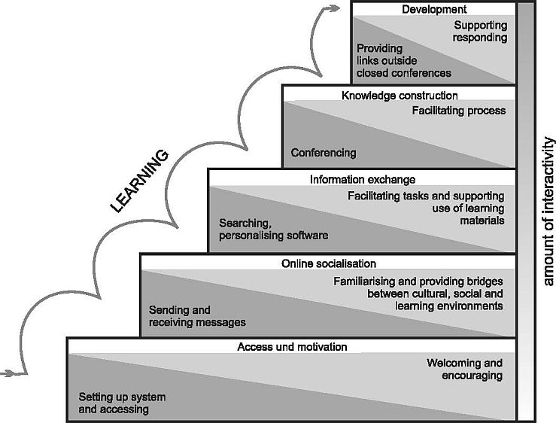

Salmon, G. (2007) ’80:20 for E-Moderators, CMS Journal, available at: <http://edoc.hu-berlin.de/cmsj/29/salmon-gilly-39/XML/Salmonl_xdiml.xml>

Suggested key approaches for early to advanced stages of group interaction are highlighted in the following table.

|  |  |  |
| --- | --- | --- |
| **Stage** | **Characteristics** | **Facilitator Activity** |
| ***Early stage***  Orientation – students getting used to what’s expected  Possible anxiety – don’t want to expose lack of knowledge/understanding  Unsure of benefit – not clear on how discussions relate to their learning | Introductions  Activities are easy to do, initially  Students are getting used to using the forum tools  Students are responding to the activity, but as a post to the instructor – they are not yet ready to respond to each other – this needs to be supported explicitly | Welcoming  Supporting  Encouraging rapport – sharing a bit about yourself  Encouraging all students to post and to respond ***to each other***  Showing an interest in background of participants  Facilitators should ensure they have a profile picture – to help build ‘social presence’  Follow up on ‘no shows’ |
| ***Intermediate stage***  Students should be feeling more comfortable with how the discussion board works  Some may be frequent posters, others may still need encouragement | Activities require more thought/effort – hopefully designed to bring about more exchange of views | Summarise points  Feedback  Encourage contributions from everyone  Ask some leading questions  Ask questions from what students have posted to try and elicit responses from the rest of the group |
| ***Advanced stage***  Group would be self-managing to a degree – exploring issues/problems themselves over and above the requirements of the ‘spark’ that is the set discussion activity | Activities have structure but there is more flexibility and scope for the group to influence how they develop ideas  Moving from ‘receiving ideas’ to generating their own | Helping to keep discussions focussed and to organise ideas  Helping to bring ideas to a conclusion / agreed set of actions |

## Further guidance

EDU recommend Gilly Salmon’s book on e-moderation[1] which is full of useful ideas and guidance on effective facilitation techniques for online tutors.

1. Salmon, G. (2011) *E-Moderating: The Key to Online Teaching and Learning*, Routledge, London.